EXERCISES
(1) What does each of the following commands do? Print the output and attach it as part of your Lab3 document:
- (a) cd /
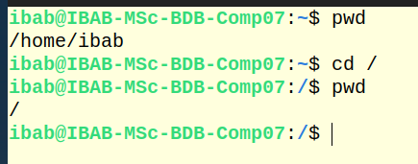

- (b) cd ~
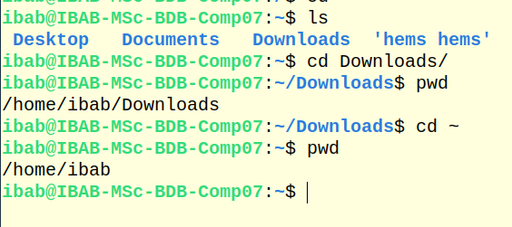
- (c) cd
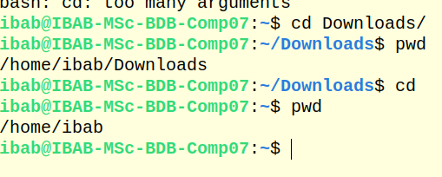
- (d) cd ..
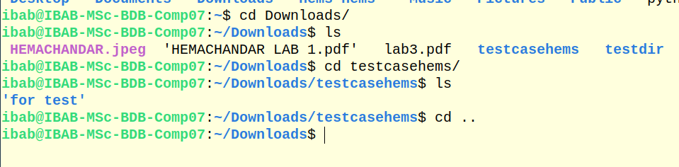
- (e) cd -
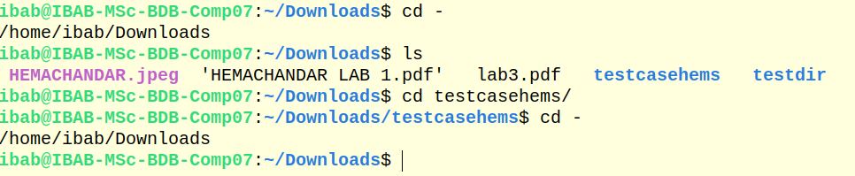
- (f) cd .
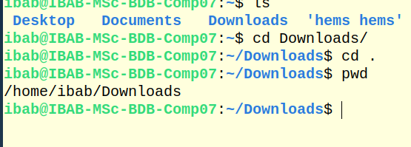

(2) When using the ls command, what is the difference between -R option and -r option? Demonstrate the difference by typing the appropriate commands and printing the output to your Lab3 document.
For ls -R
Lists all files and directories recursively
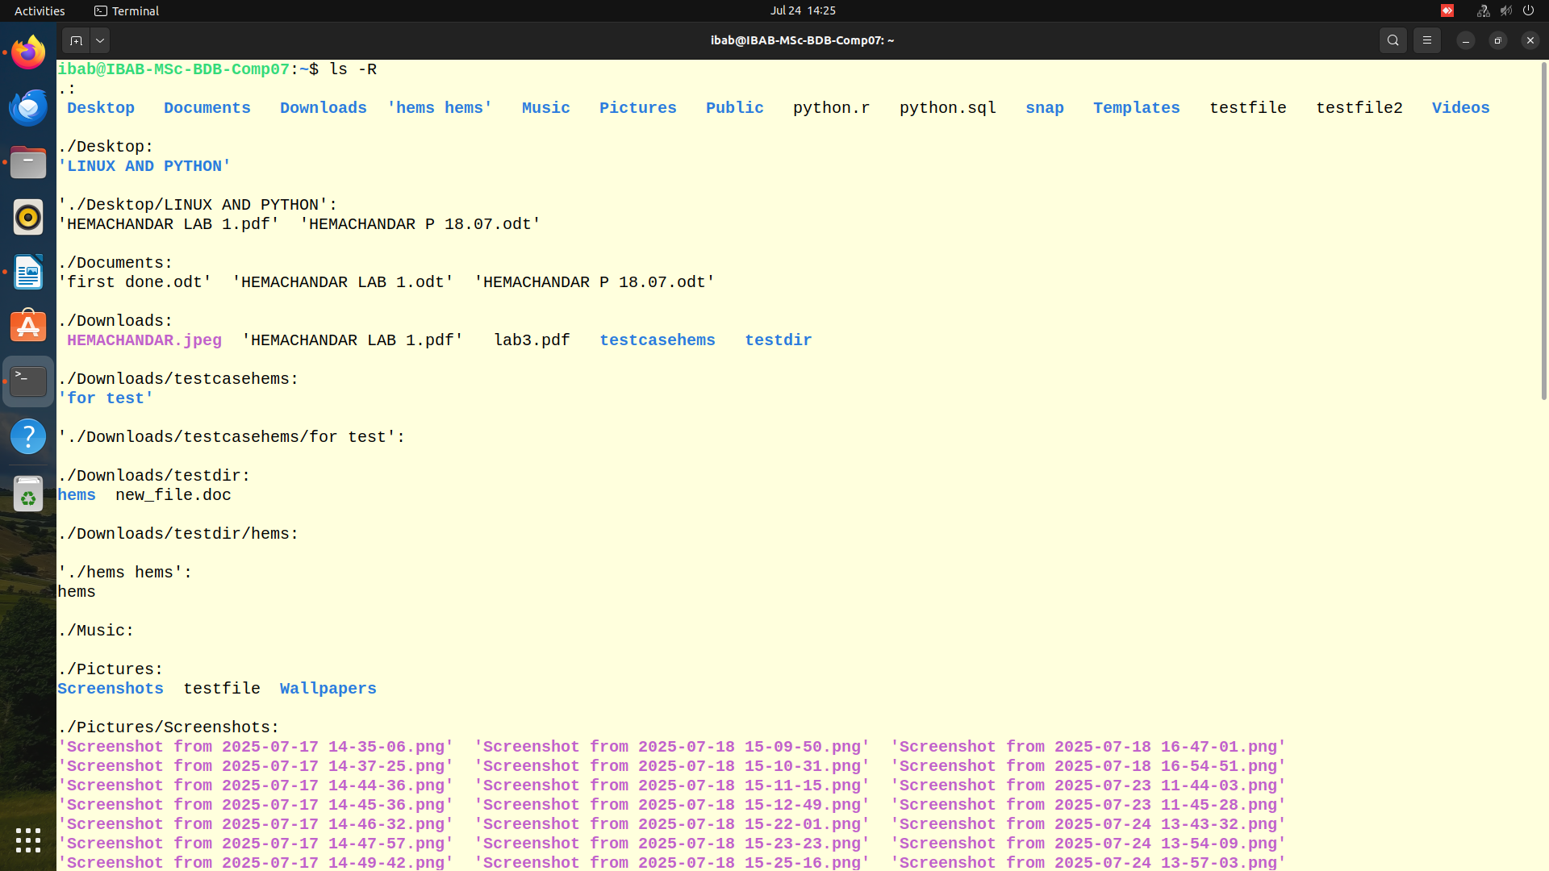
ls -r
Lists the files and directories in reverse order
(3) How do I find out what directory I am currently in?
By typing pwd we can check where we are.

(4) How do I list files sorted by modification time, but with oldest first?
Find the correct combination of options to do this task. Print the output of your command with appropriate screenshots to demonstrate this in your Lab3 document.
For ls -t
It will come as newest first
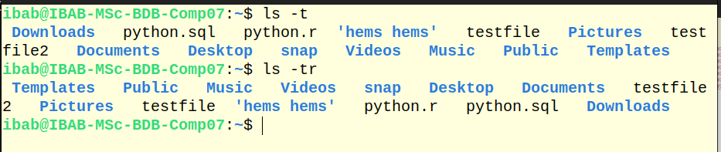
For ls -tr
It will come as oldest first(i have attached the screenshot above)
(5) What is the difference between (explain in your own words) ls -ltr and ls -1? Demonstrate the difference with appropriate screenshot and explanations.
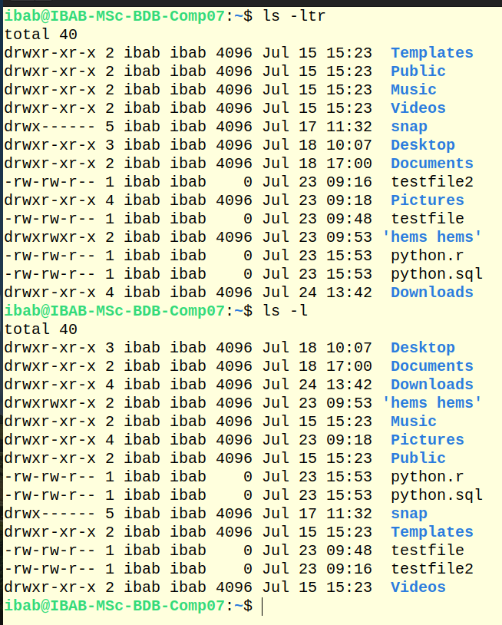

By giving ls -ltr it will give in the oldest to newest order in which it has created ;
Whereas,
ls -l gives no extra details, no sorting by time just a clean, vertical list Useful for scripts or simple viewing.

(6) What is the difference between ls -alF, ls -A and ls -CF.
Demonstrate the differences with appropriate examples as screenshot and explanations.

1. ls -alF
Lists all the files in the long listing format

2. ls -A
List all the files except current directory and parent directory and here also it will show the hidden files

3. ls -CF
Lists entries in columns
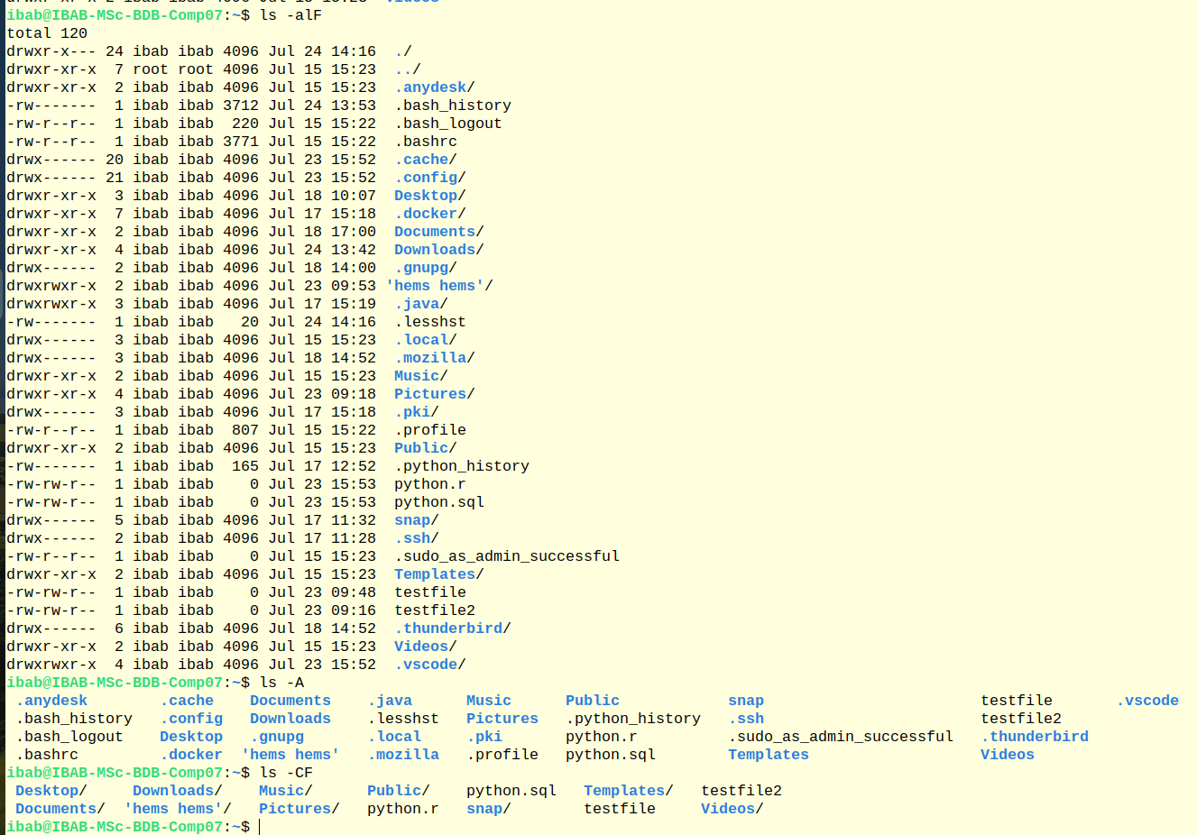

(7) Describe how you would use a combination of color codes in the command prompt appearance. Demonstrate this using an example where you managed to combine the colors blue and green?

(8) Find the option of ls that lists the contents of a directory in the long format, but without the primary group information.
(Note: ls -l lists files in the long format with the primary group information)
ls -lGa

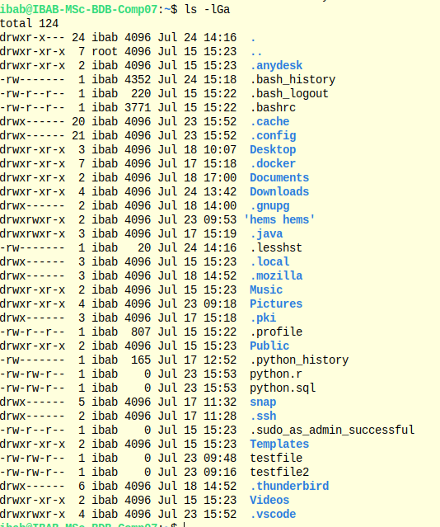

(9) Download the etc.zip file sent to you by email, unzip it and rename it as etc_learn.
Change your directory to etc_learn. In this directory do the following using the necessary wildcards:
- (a) List the files or directories starting with b
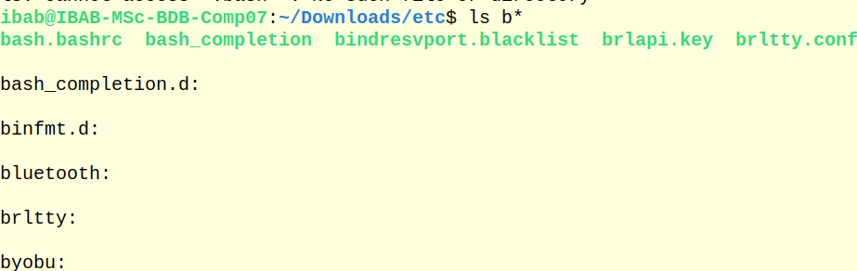
- (b) List the files or directories starting with any of the letters from a-k
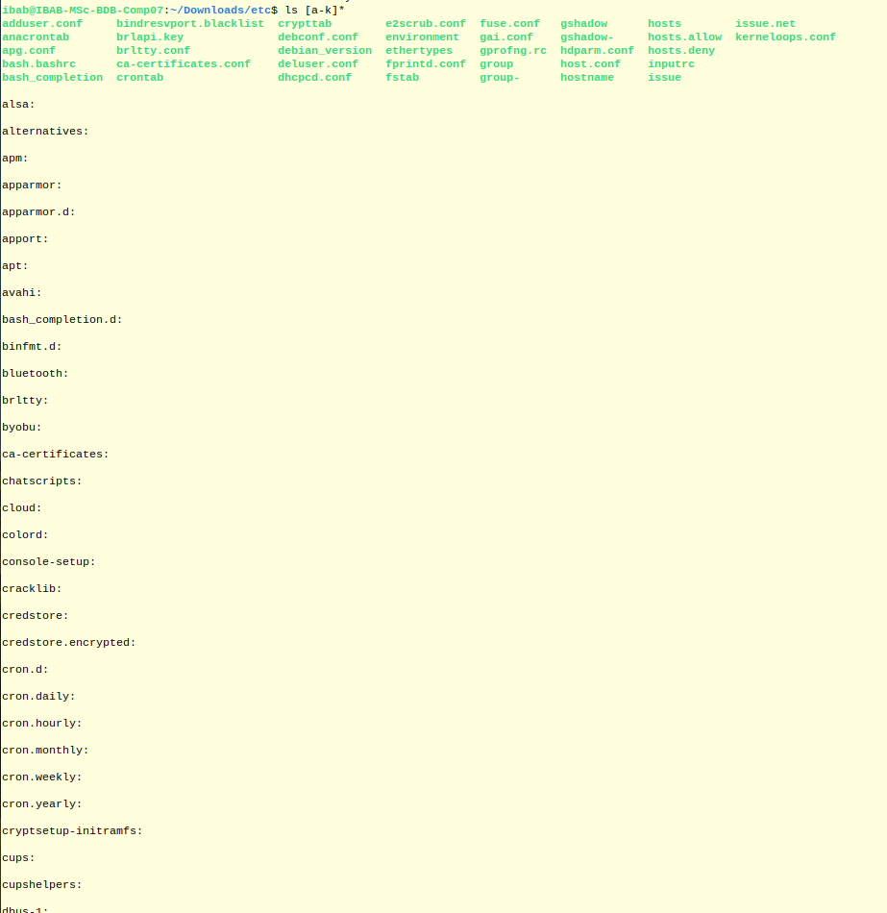

- (c) List files or directories ending with d
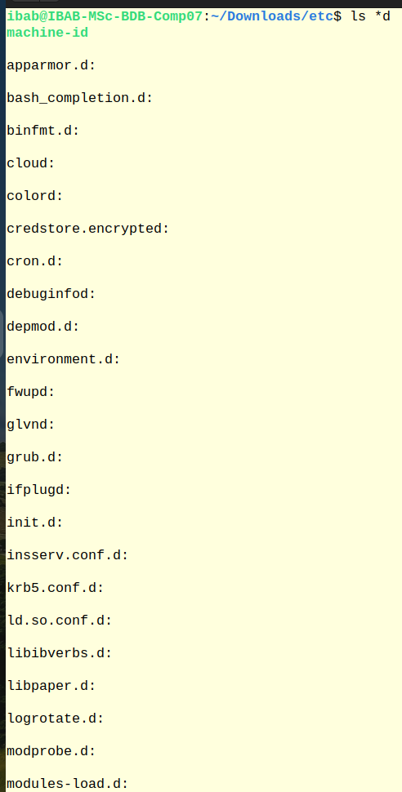

- (d) List the files or directories containing the pattern with .conf. How many are there?
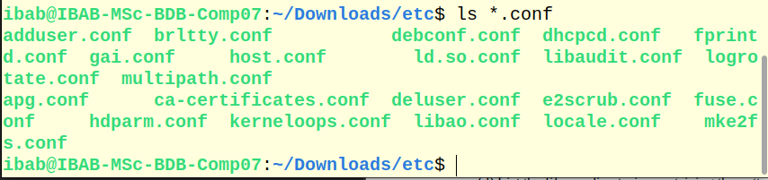
- (e) Output the last three lines of the file /etc/resolve.conf
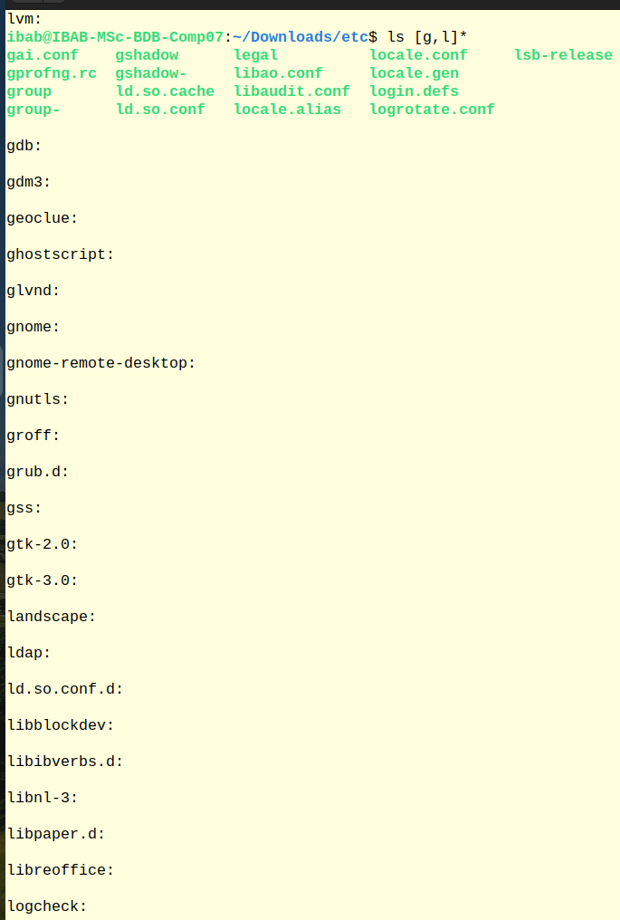
- f) List files that begin with g or l

(10) Create the following directories:
/home/ibab/lab3/Q10/q1 and /home/ibab/lab3/Q10/q2 using one command. Attach a screenshot of the commands and the outputs of this and below exercises in your document:
- (i) Enter the q1 directory using one command
- (ii) Change directories from q1 to q2 using one command
- (iii) Copy the q1 directory to q1_copy
- (iv) Delete the q1_copy interactively
